VICTORIAN BUSH POETRY AND MUSIC ASSOCIATION INC (5 member groups)
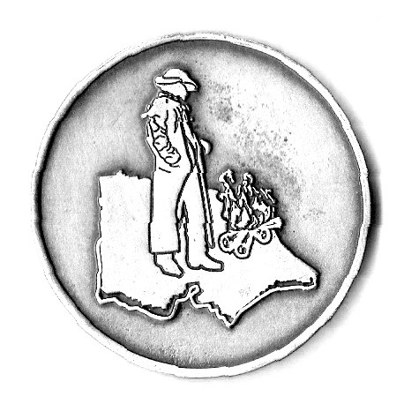 Australian Bush Poetry is family entertainment, written abut Australians and the Australian way of Life.
It is rhyming metered verse, in the style of Henry Lawson & A B (Banjo) Paterson.
We perform Traditional, Modern and Original items as Yarns, Poems and Songs.
VBPMA Secretary: Liz Dorsett 0428775033
President: Tim Sheed 0438861271
Treasurer: Christine Middleton 0419526550
Membership Application Form Victorian Bush Poetry & Music Association Inc.

Name: ……………………………………………… Membership number……………….
Postal address: ……………………….
Postcode:……….. Phone:…………………………. Mobile:……………………………..
Email: Facebook? ……yes/no
Signature: …………………………………..Date……………………….
VBPMA Membership Fees: (AUD) please tick/circle New or renew (tick which)
Single membership $10
Dual membership $15 in one household
Group membership $10
Junior membership (under 18 years) $5
Supporter…. Donation. $.............

Membership is for a calendar year from 2nd Sun in October to 2nd Sunday in October the following year.
Annual membership includes occasional emails/news re poetry events (also Facebook see below)
plus information for both Annual Muster and Man from Snowy River Bush Festival.
AGM IS HELD AT THE COMPLETION OF ANNUAL MUSTER.
VBPMA will not share your details with any other group.

I do/do not require a receipt
Circle payment Method: cheque money order Direct Debit
Cheque/money order payable to Victorian Bush Poetry & Music Association Inc. TOTAL $...............
Payable to: Christine Middleton, Treasurer
P.O. Box 357, Portarlington. Victoria 3223
Direct Deposit - Bank: Bendigo Bank Acc name: VBPMA Inc BSB 633108 Acc. No: 142764125 (please ref your name)
Enquiries: Tel. 0419526550 EmaiL: christine.mi@bigpond.com
Web: www.vbpma.com.au Facebook www.facebook.com/groups/vicpoets

